**1)Construct CLR parsing table for the grammar S->CC C->cC | d.**

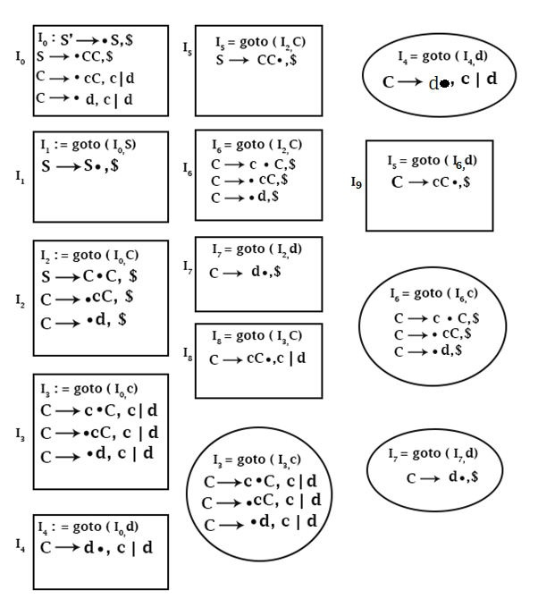

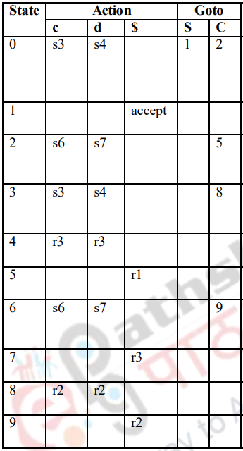

**2) b) Compute First and Follow for the grammar E->E+T/T, T->T*F/F, F-> (E)/id.** 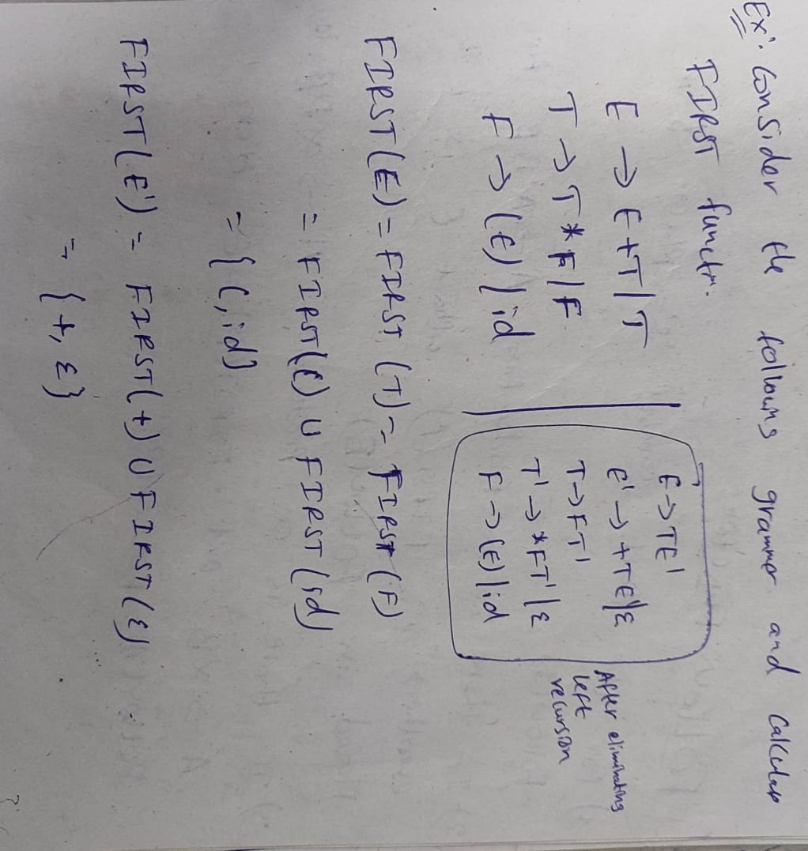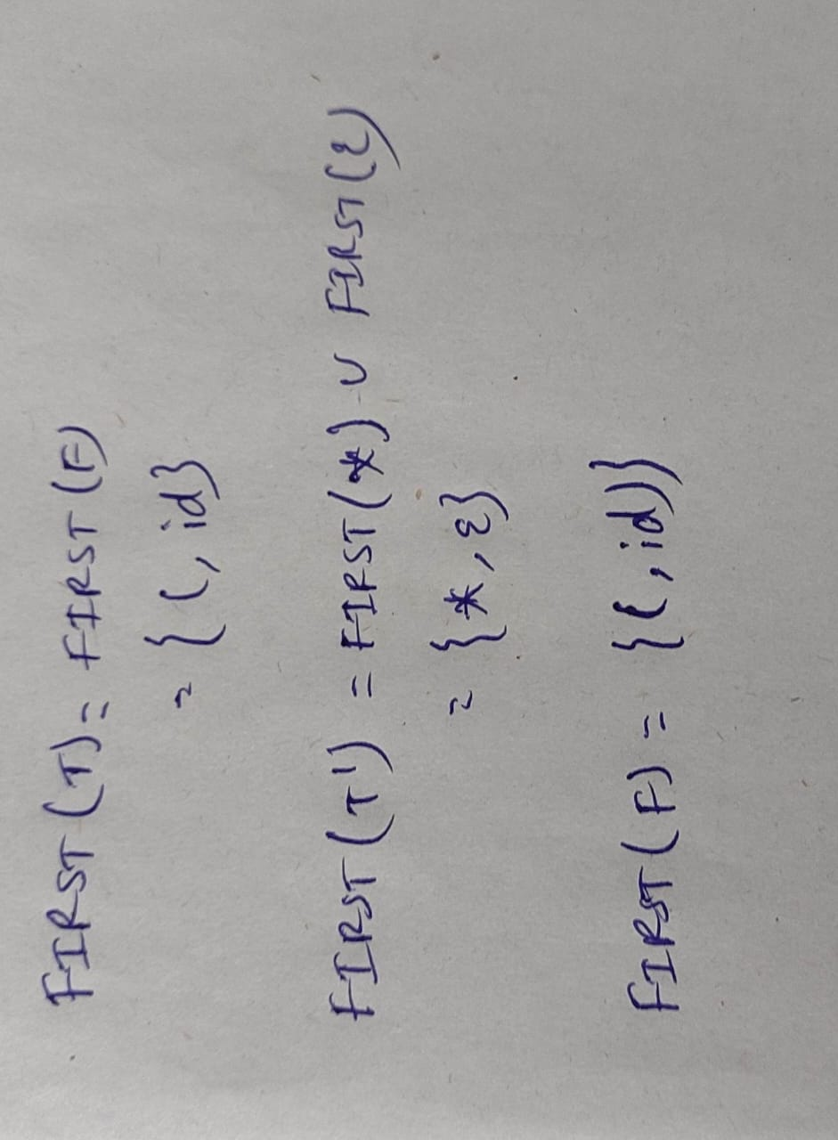

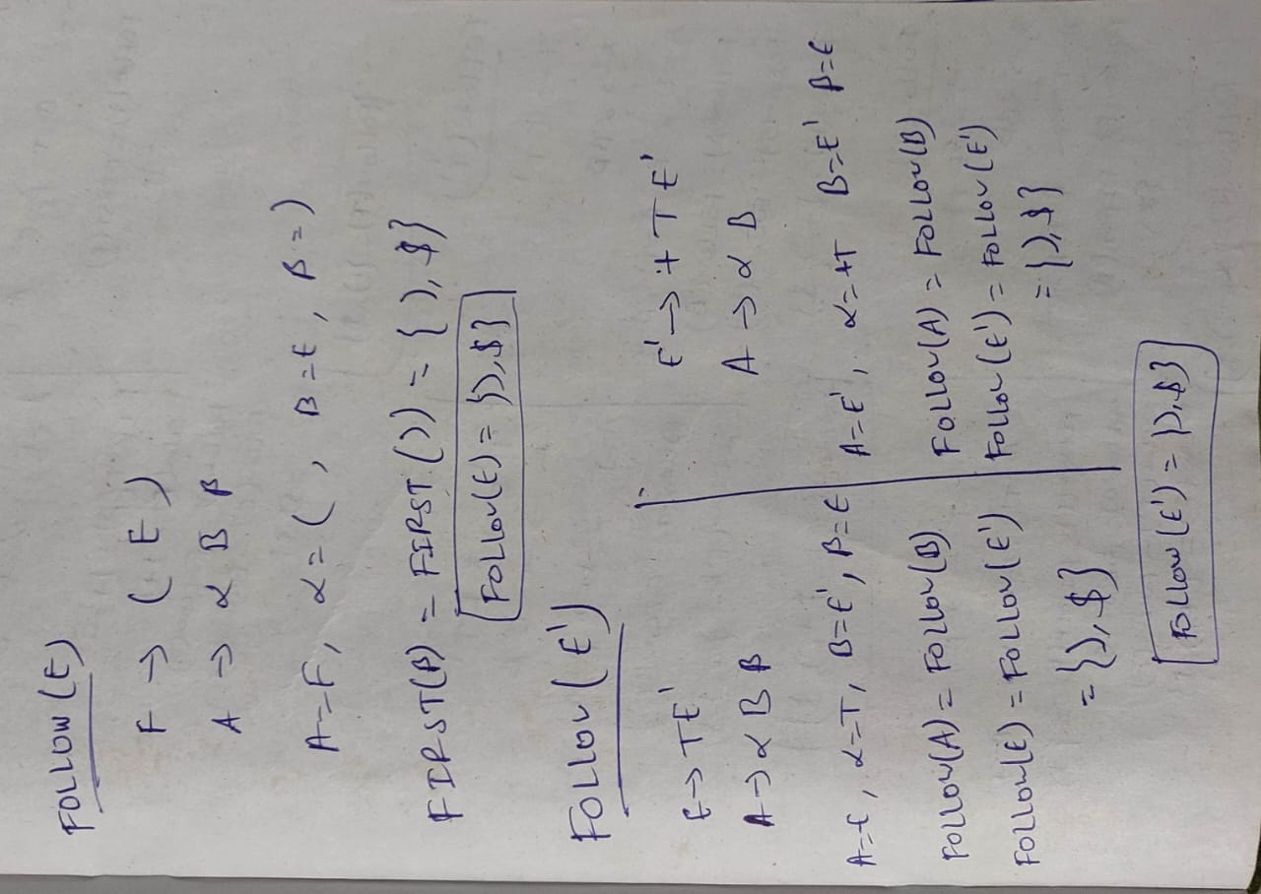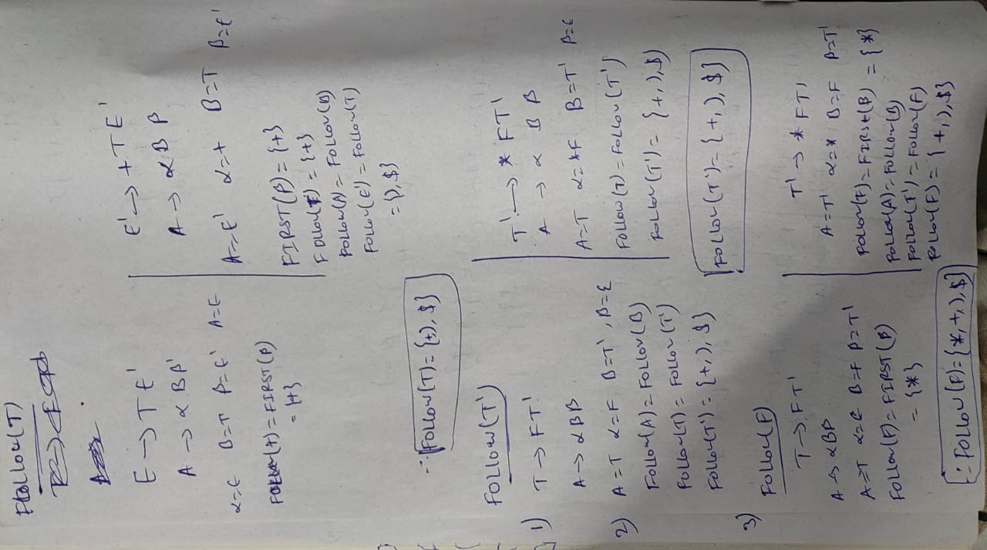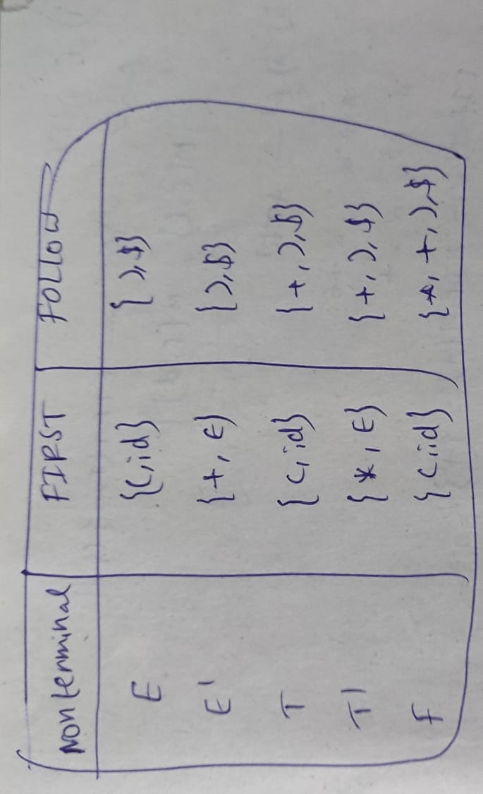

**3) a) Illustrate recursive descent parser for the grammar. S->cAd A->ab|a with a string cad**

**3) b) Construct the LL (1) for the following grammar S–>(L) | a L–>L, S | S**

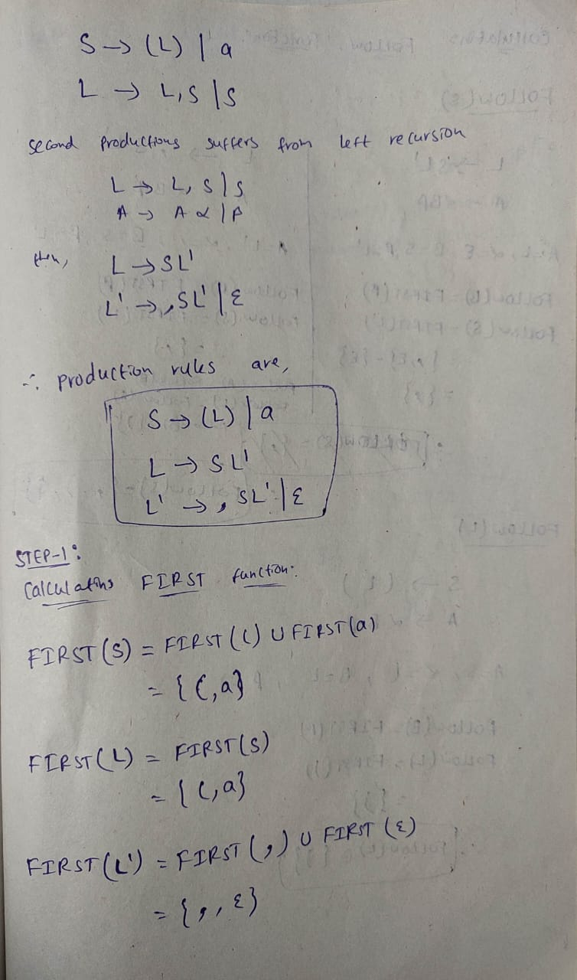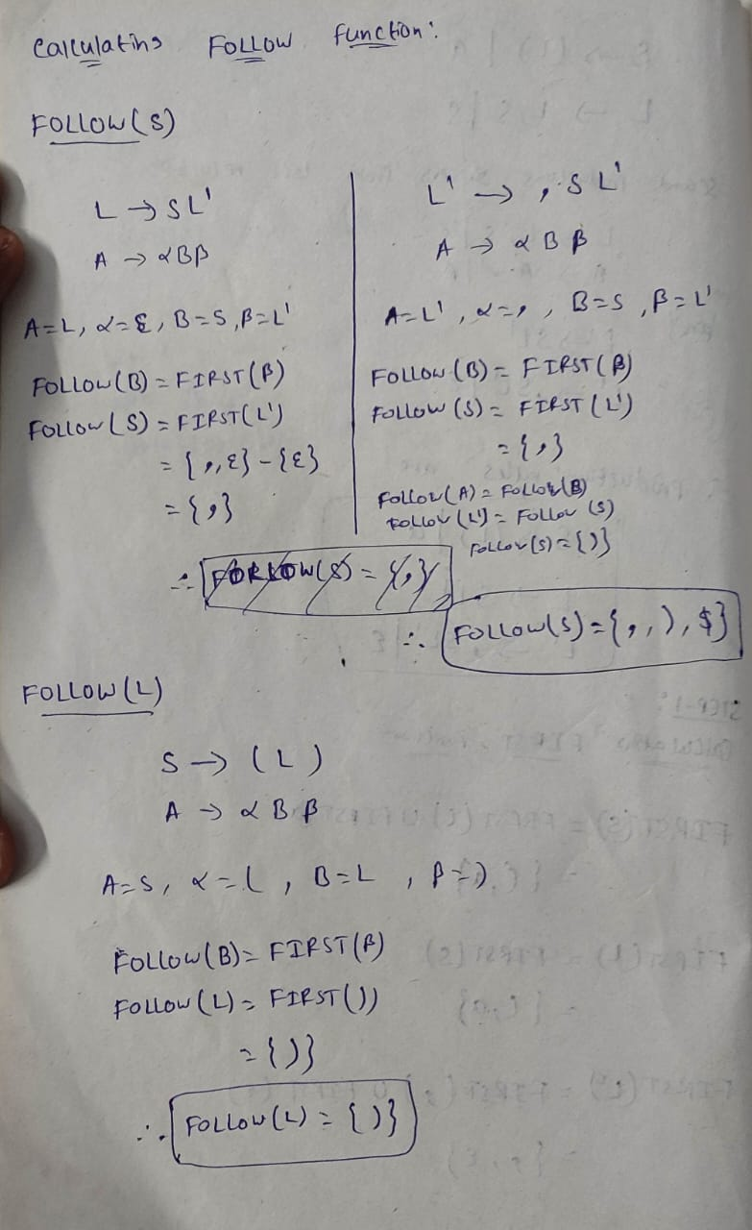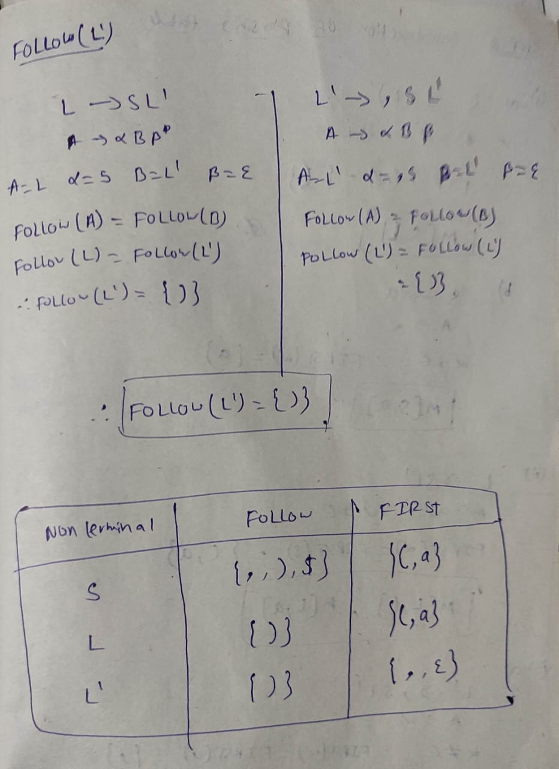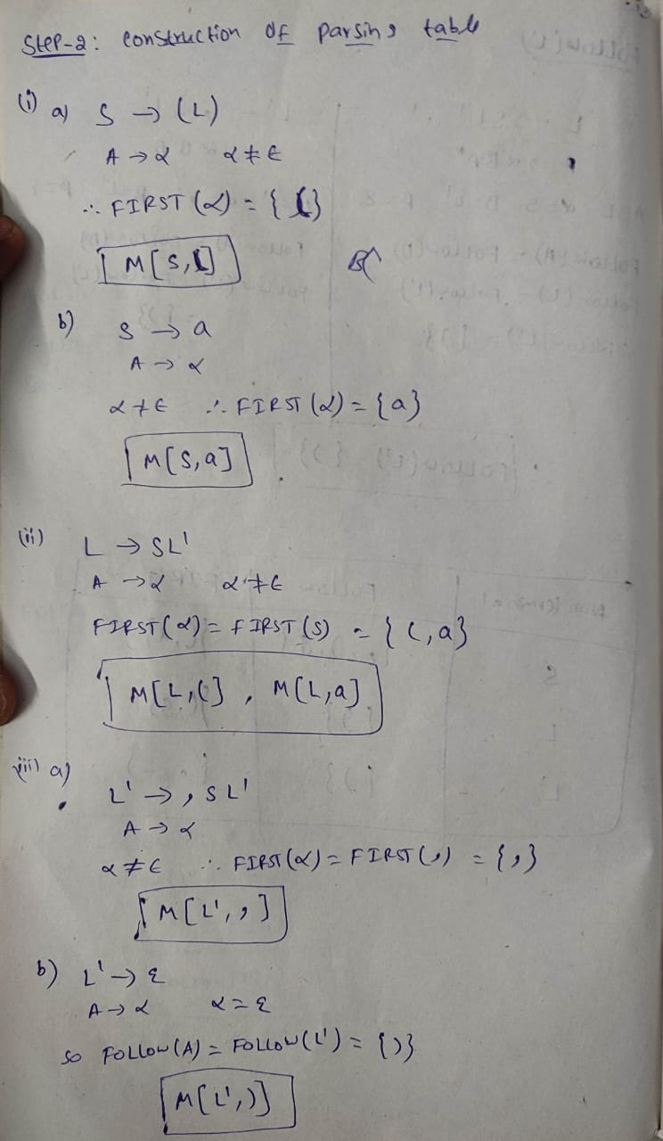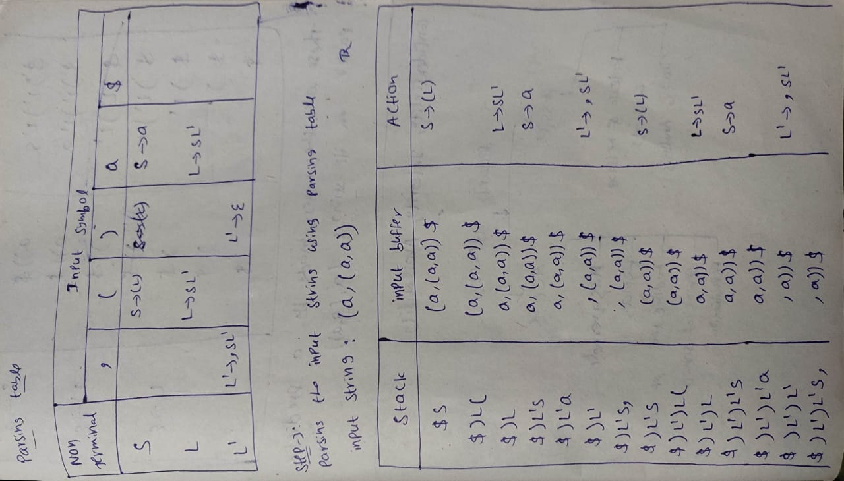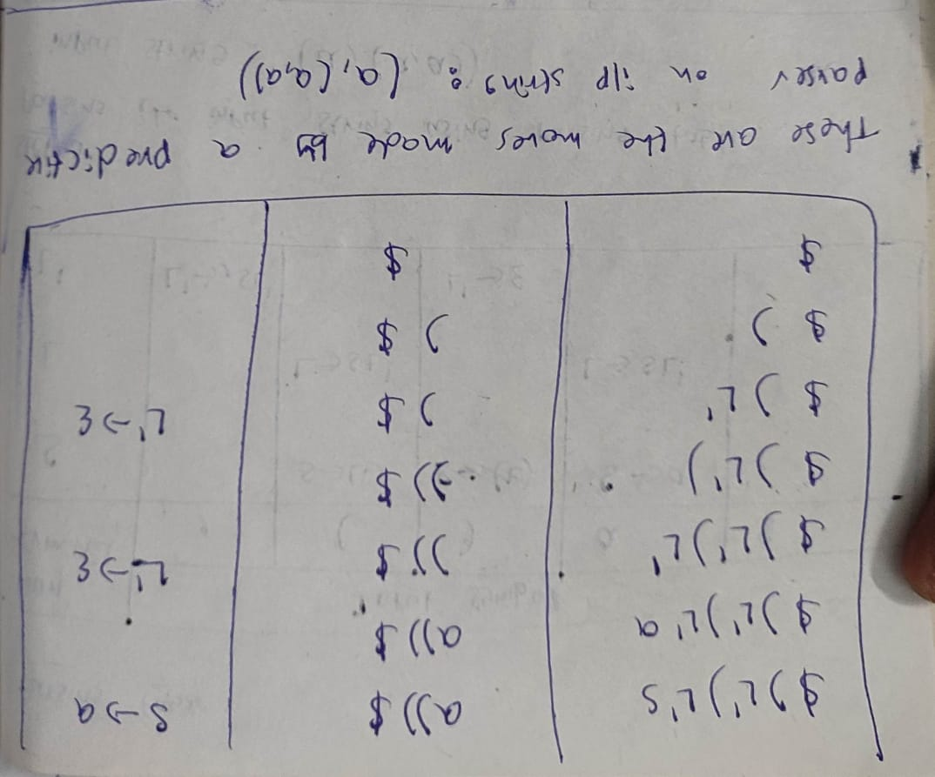

**5)a) Construct predictive LR parsing table for the grammar S->iEtSeS | iEtS |a E->b.**

**5)b) Explain in brief about the shift reduce parser with example.**

EXAMPLE:

Consider,

E -> E-E

E-> E*E

E->id

Input string: id – id * id

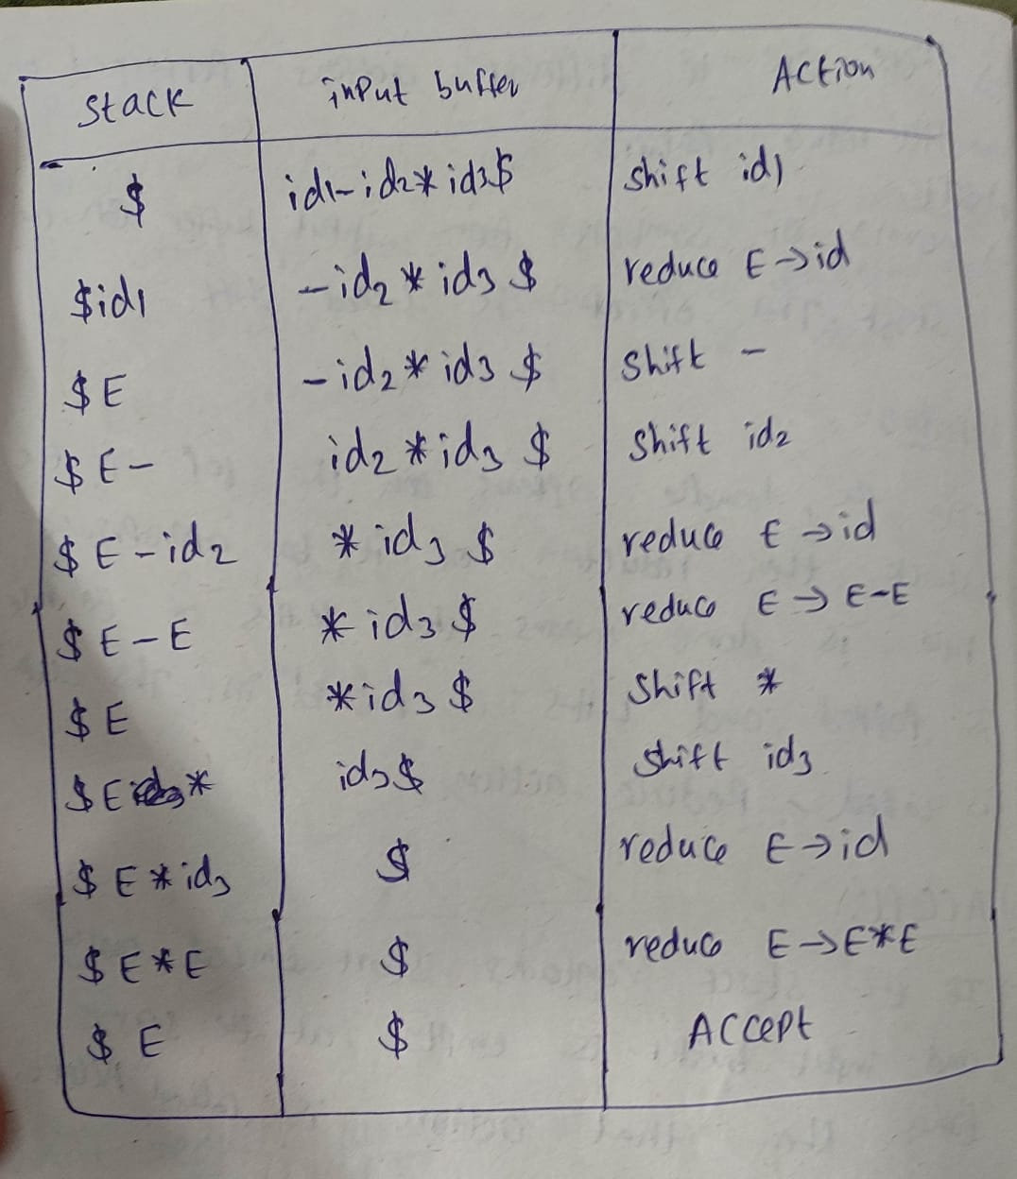

**6) b) Construct the LR parse table for the given grammar. E->E+E E->E*E E->E-E E-> (E) | id.** 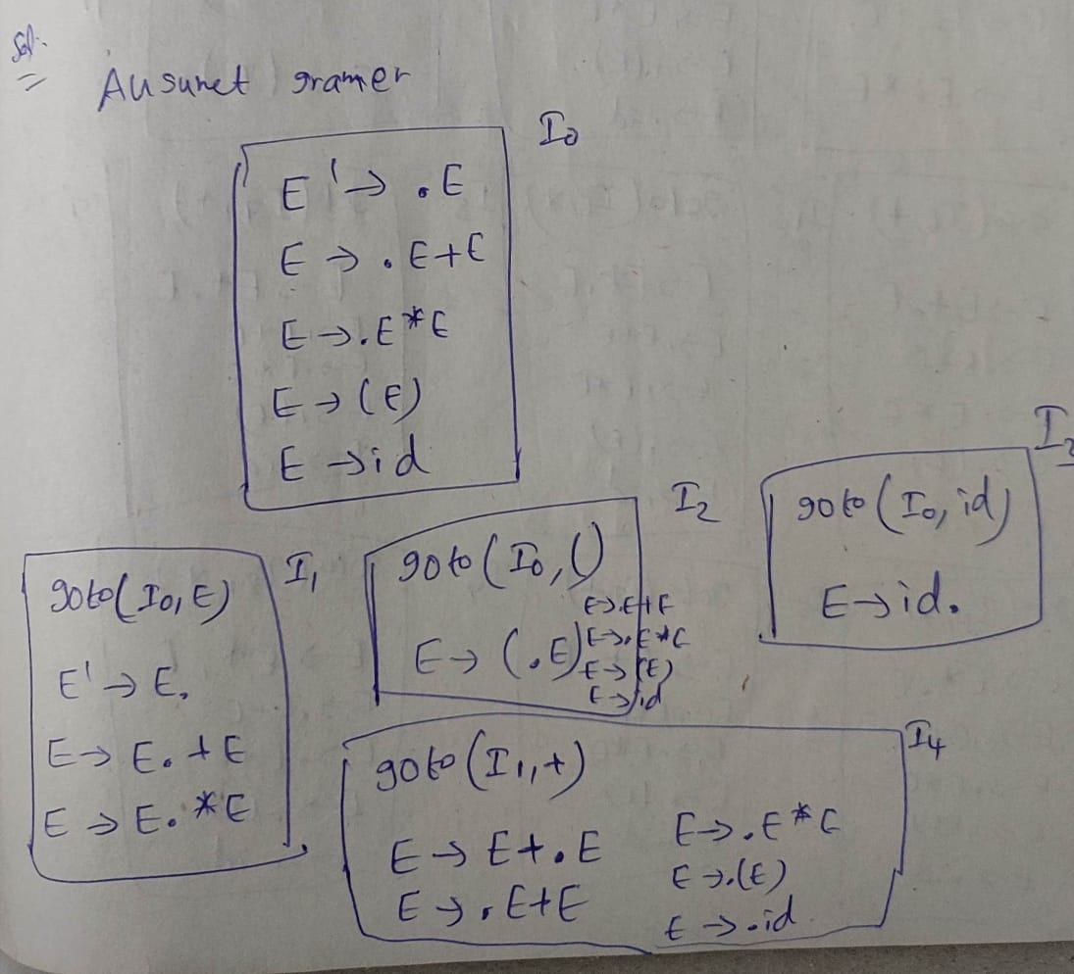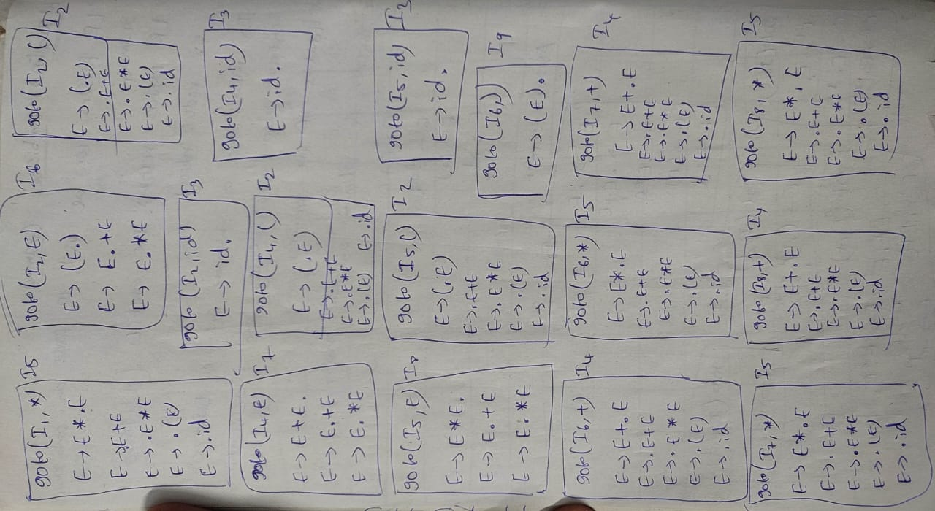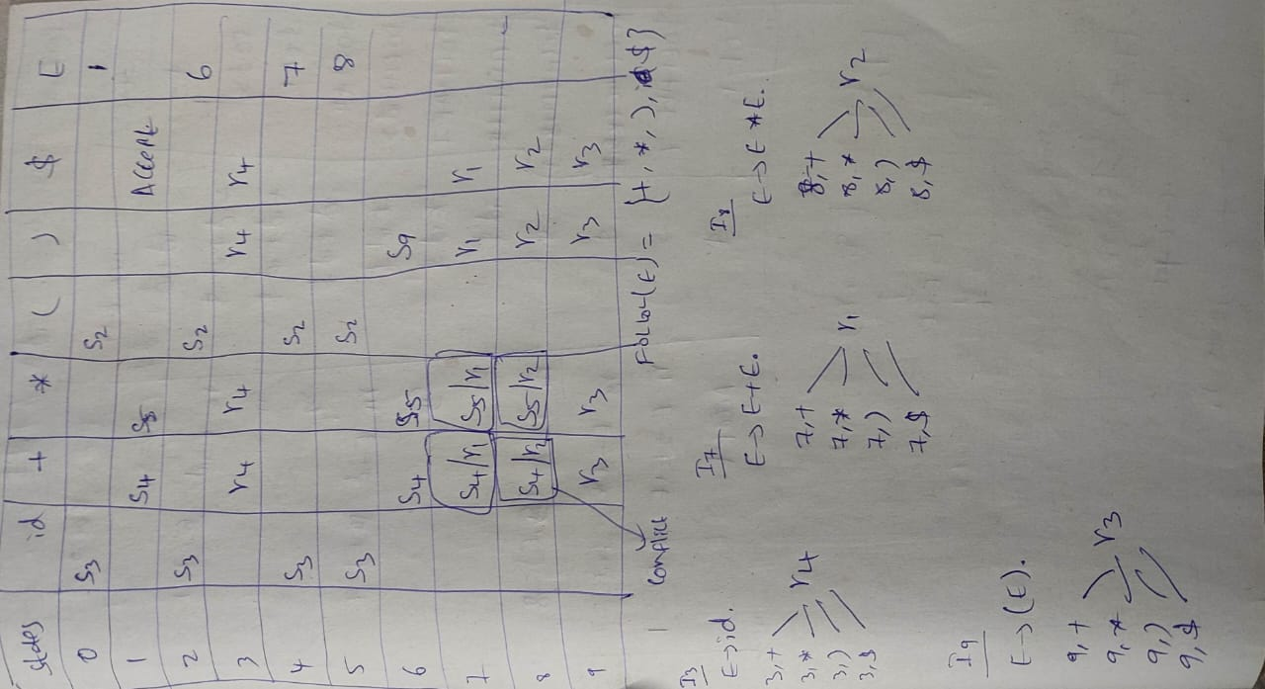

**7)Find the validity of the input string “id+id*id“by the SLR parser for the given grammar E->E+T | T T->T*F | F F-> (E) | id.**

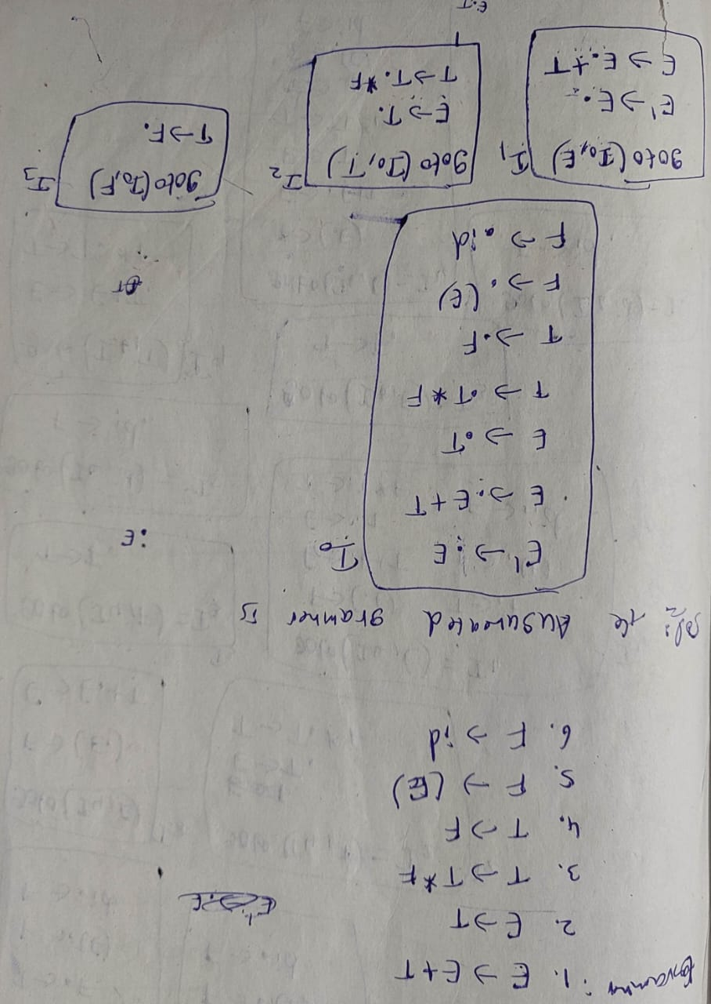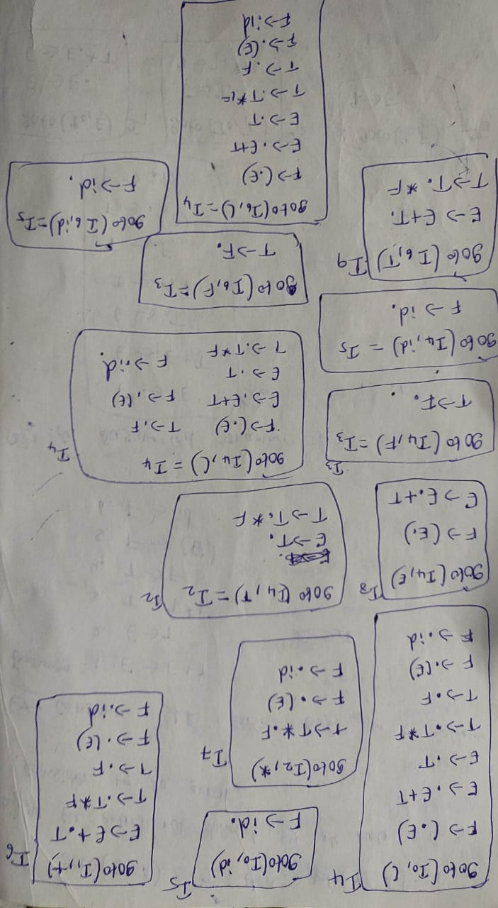

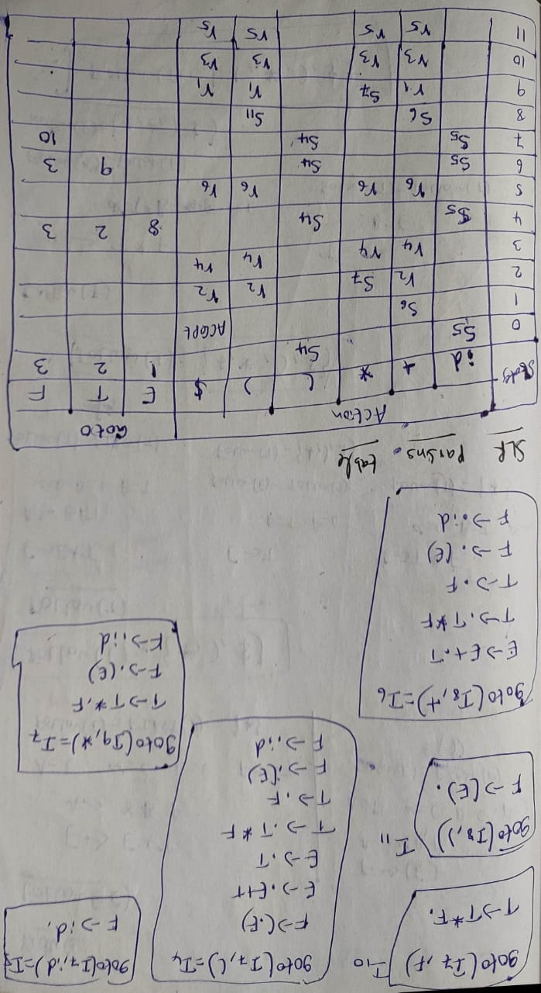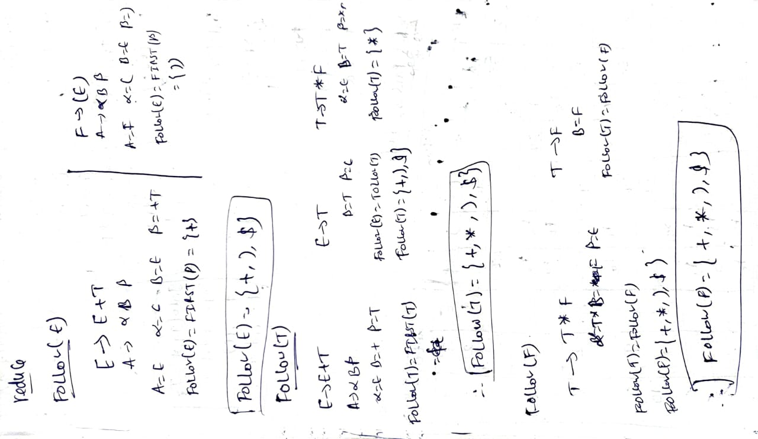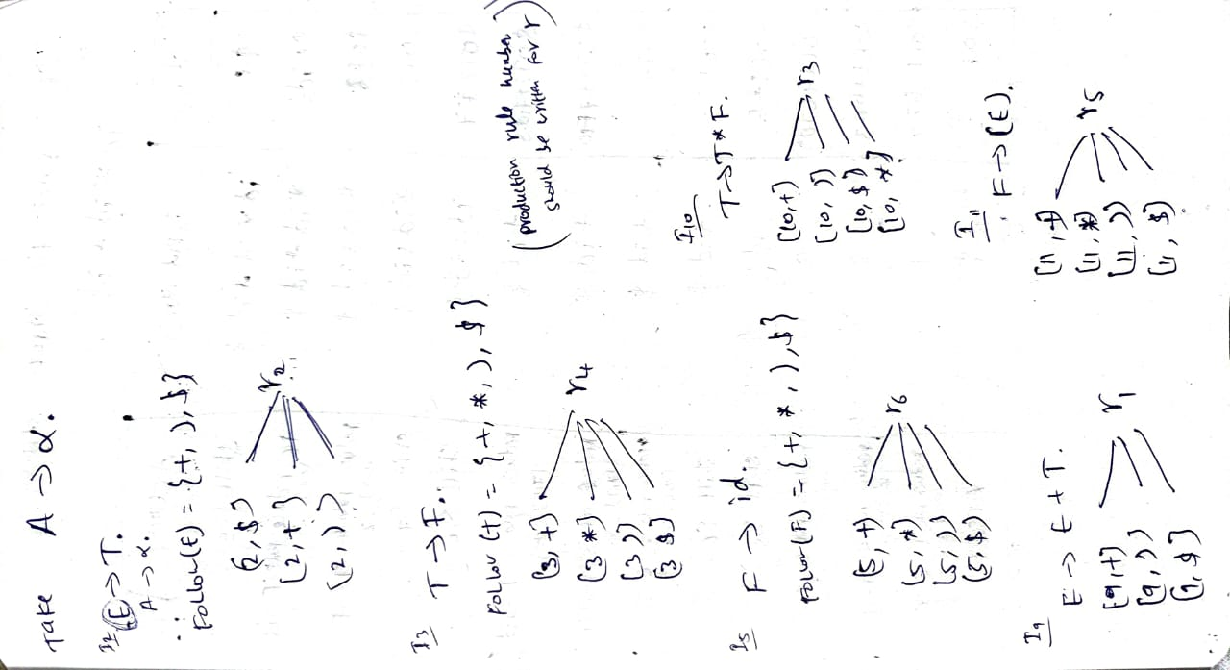

**8) Construct LR (1) parsing table. S->Aa , S->bAc ,S->Bc ,S->bBa ,A->d,B->d is LR(1)**

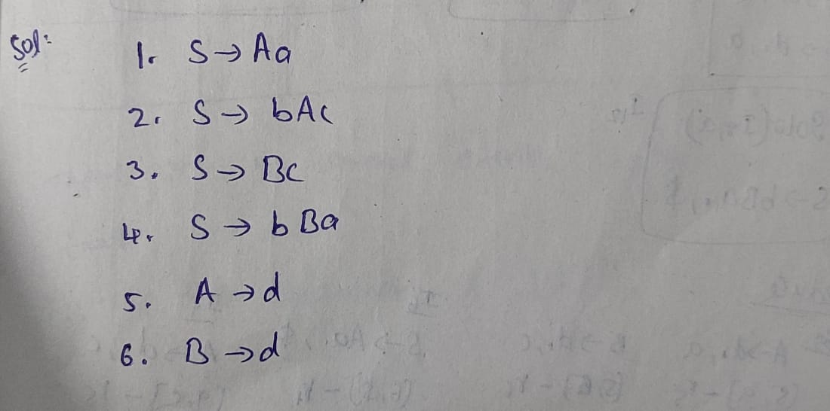

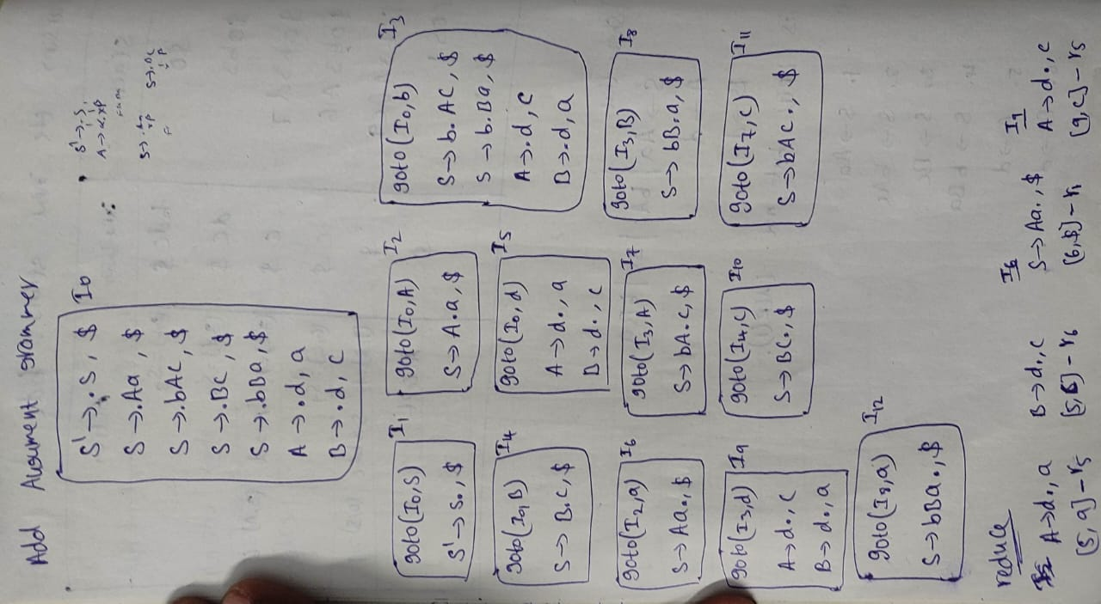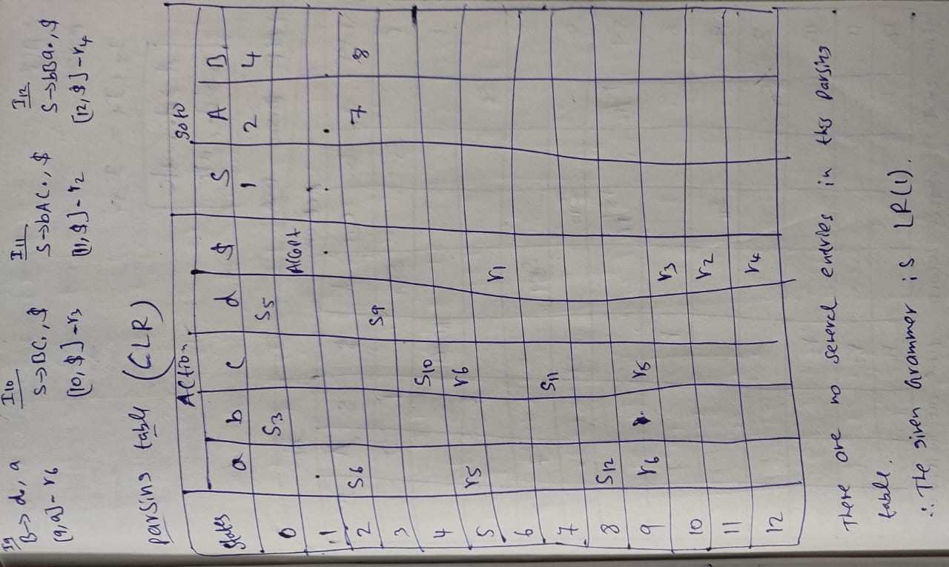

**9) Construct the CLR parsing table for the following grammar: S->L=R | R L-> *R | id R->L**

